Experiment:- 4

PROBLEM STATEMENT:-
Efficient file management is a critical requirement in Linux-based systems, especially for system administrators and cyber security professionals. Linux provides powerful command-line utilities that allow users to create, copy, move, rename, view, and delete files efficiently. Understanding these commands is essential for organizing data, managing logs, and automating tasks using scripts. The problem is to practice Linux commands for deleting, copying, moving, renaming, and displaying files, and to understand the use of input/output redirection for managing command outputs.

Aim:- Deleting, Copying, Moving and Renaming files in linux

Procedure:-
1.Log in to the Linux system and open the terminal.
2.Create a working directory: mkdir file_ops , cd file_ops
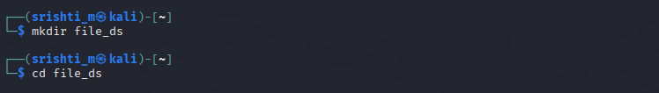
3.Create files using touch
4.Add content to files using redirection.
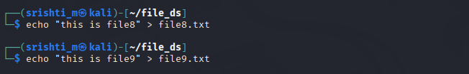

5.Display file contents.
6.Copy a file.
7.Rename a file
8. Move a file to another directory: mkdir backup mv copy_file1.txt backup/
9. Append content to a file: echo "Additional content" >> file1.txt
10. Delete a file: rm renamed_file2.txt
11. Verify changes using: Ls
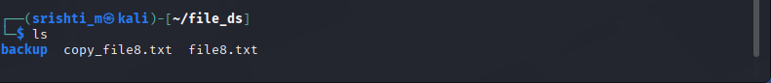

Expected Output
• Files created, copied, renamed, and deleted successfully.
• File contents displayed correctly.
• Output redirection works as expected.
Result
Linux file operations including copying, moving, renaming, deleting files, and output redirection were successfully performed using command-line utilities.

